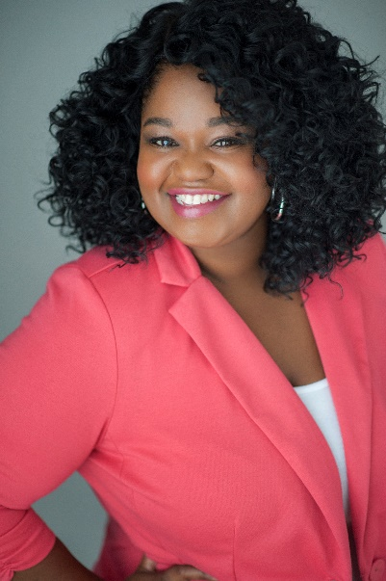
CANTRELLA CANADY
239-823-2681
info@cantrellacanady.com
www.cantrellacanady.com

Hair Black
Eyes Dark Brown
Height 5’7”
Weight 260 lbs.
Vocal Range Alto/Mezzo-Soprano

THEATER

PRODUCTION ROLE COMPANY DIRECTOR
Spring Awakening Adult Woman Florida Repertory Theatre Kody C. Jones
Little Shop of Horrors Crystal Broadway Palm Dinner Theater Amy McCleary
Andorra The Innkeeper The Laboratory Theater of FL Annette Trossbach
Show Boat Ensemble Gulf Coast Symphony Max Quinlan
Joe Turner’s Come and Gone Martha Pentecost Theatre Conspiracy Sonya McCarter
Saturday Night Fever Candy (Understudy) Broadway Palm Dinner Theater Amy McCleary
Madagascar: A Musical… Gloria Broadway Palm Dinner Theater Paul Bernier
A Raisin in the Sun Ruth Theatre Conspiracy Sonya McCarter
Sister Act: The Musical Deloris Van Cartier Cultural Park Theater Gerri Benzing
The Pajama Game Mabel Cultural Park Theater Robin Dawn Ryan
Seven Guitars Ruby Theatre Conspiracy Sonya McCarter
Sister Act: The Musical Tina/Nun #5 (Deloris Understudy) The Naples Players Dawn Labrecht Fornara
Ma Rainey’s Black Bottom Ma Rainey Theatre Conspiracy Sonya McCarter
All Shook Up Sylvia (Understudy) Cultural Park Theater Robin Dawn Ryan
The Country Wife Lady Fidget Theatre Conspiracy Karen Goldberg
The Bluest Eye Claudia Theatre Conspiracy Sonya McCarter
Mr. Burns, A Post-Electric Play Quincy/Bart Simpson Theatre Conspiracy Rachael Endrizzi
For colored girls who have… Lady in Green Theatre Conspiracy Patricia Idlette
WEB

PRODUCTION ROLE COMPANY DIRECTOR
The Blood Drawn Chronicles Oriana (Voice-Over) Digifox Studios Michael Bradley
EDUCATION

Graduated May 2016 Florida Gulf Coast University B.A. in Communication, Minor in Theater

